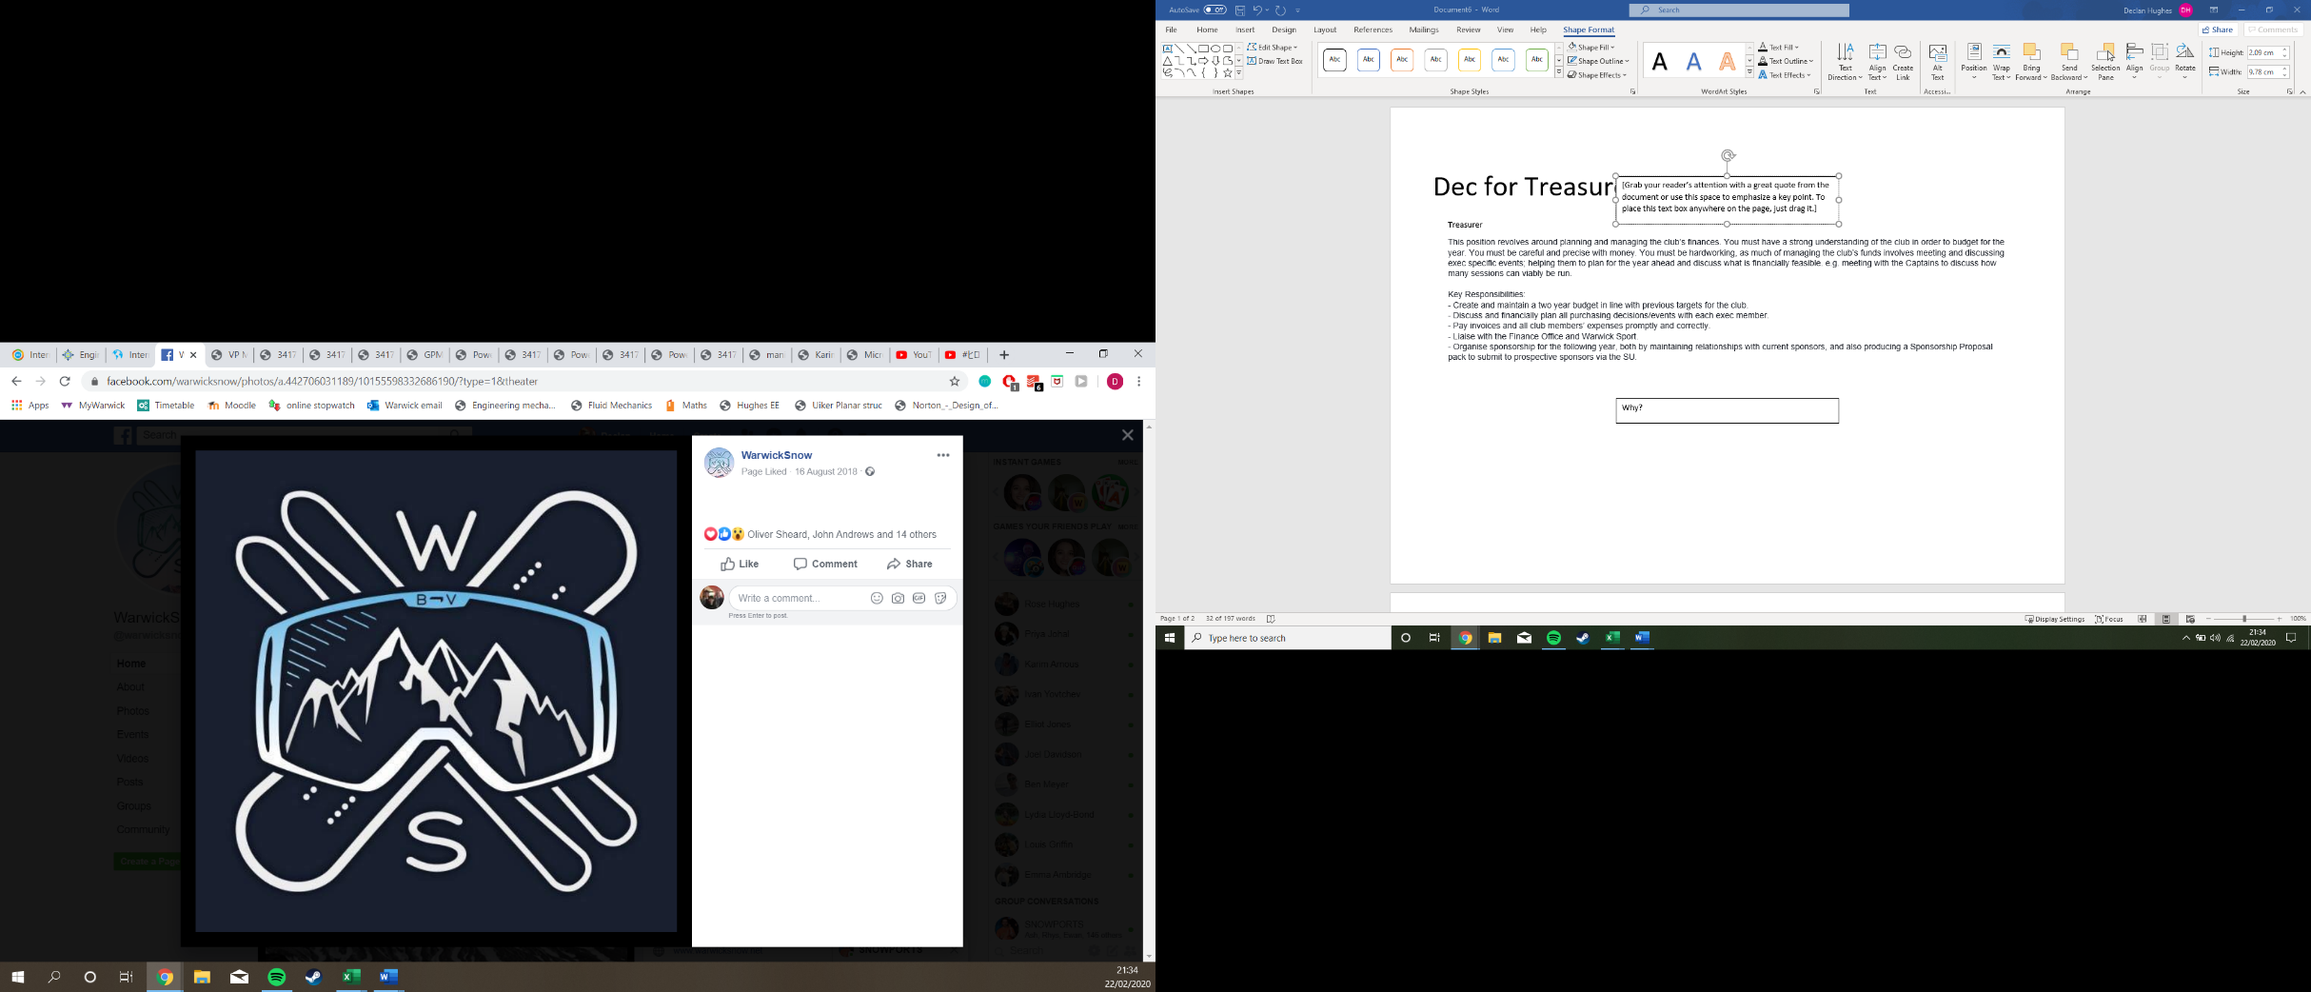

**Who???**

I’m a 2nd Year Mechanical Engineer with about 8 years of ski experience

First full year in Snow and consistent presence at socials with 2 Tours under my belt and many more on the way (is masters worth it for the tours?)

**Dec for Treasurer**

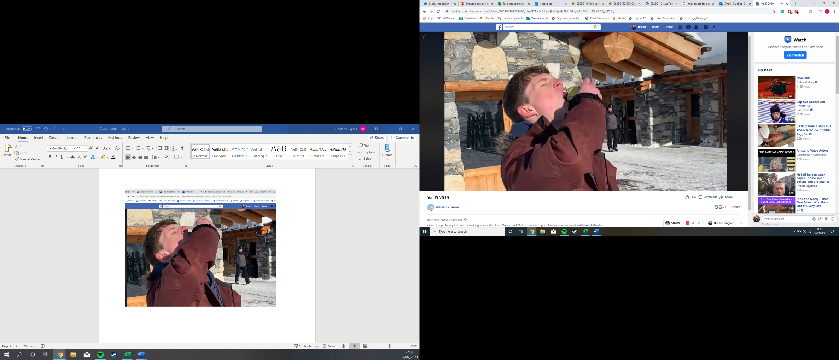

**Why am I running?**

Having loved my first full year in snow with too many great, drunken (forgotten) nights to count (ironic (because treasurer (Ha))). I’m ready to take this passion to the next level by ensuring next year’s warriors have as much fun as I have had this year by running for treasurer. I’m confident in my ability to learn if need be and will actively do my best to support others while fulfilling my roles to the highest degree.

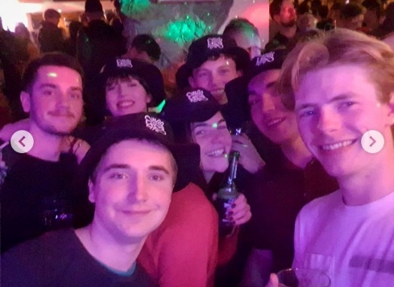

**Why vote for me??**

**M**aintain close relations with current sponsors while looking for new sponsors because mo money isn’t mo problems. Also maintain the friendly atmosphere snow is revered for.

**O**rganised – (at least 40 tabs open at once for maximum productivity) Will work with captains, social sec and other exec to properly plan and communicate events along with deciding on purchases.

**N**o hassle – “Refund” is all I need to hear 🡪 forms submitted quickly

**E**ngineer- (had to mention it), love a bit of maths so the budget will be done over the summer, also work with exec to adjust budget in line with future ideas.

**Y**ou will be making the right choice; while still requiring a lot of hard work, treasurer is one of the more passive roles in the exec on a day to day basis meaning meetings, promo and liaising with the finance office can be done to support the other exec.

**Ideas for the money:**

* Adjust budget to help support racing for captains and others that want to get involved.
* Maintain taster sessions as freestyle sessions were praised

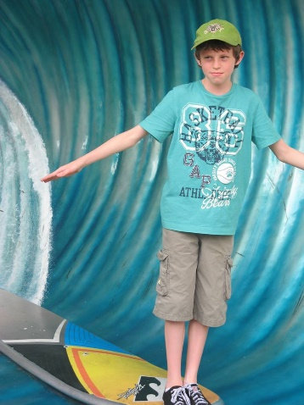

Surf was never an option…